**Web &**

**Internet**

**Class Five**

**Lab 11**

|  |
| --- |
| Lab Objectives:  * Web browser |

# Using a web browser

## A web browser is a type of software that allows you to find and view websites on the Internet. There are many different web browsers, but some of the most common ones include Google Chrome, Internet Explorer, Safari, Microsoft Edge, and Mozilla Firefox.

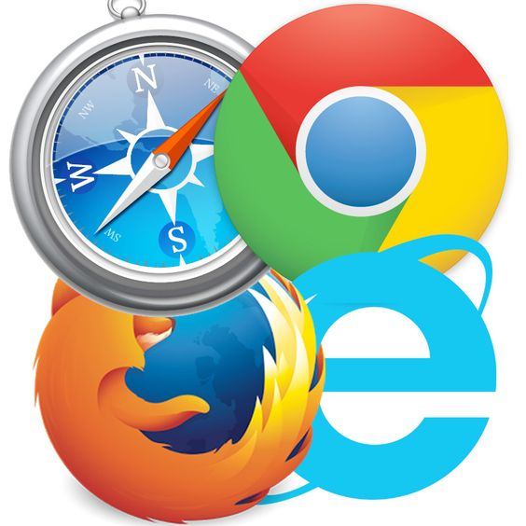

## No matter which web browser you use, you'll want to learn the basics of browsing the Web. In this lesson, we'll talk about navigating to different websites, using tabbed browsing, creating bookmarks, and more.

## We'll be using the Google Chrome web browser throughout this lesson, but you can use any browser you want. Keep in mind that your browser may look and act a bit differently, but all web browsers work in basically the same way.

# URLs and the address bar

## Each website has a unique address, called a URL (short for Uniform Resource Locator). It's like a street address that tells your browser where to go on the Internet. When you type a URL into the browser's address bar and press Enter on your keyboard, the browser will load the page associated with that URL.

## In the example below, we've typed [www.bbc.com/travel](http://www.bbc.com/travel" \t "/home/deepto/Documents\\x/_blank) into the address bar.

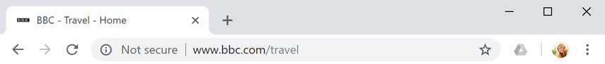

# Links

## Whenever you see a word or phrase on a website that's blue or underlined in blue, it's probably a hyperlink, or link for short. You might already know how links work, even if you've never thought about them much before. For example, try clicking the link below.

[Hey, I'm a link! Click me!](http://www.google.com" \t "/home/deepto/Documents\\x/_blank)

## Links are used to navigate the Web. When you click a link, it will usually take you to a different web page. You may also notice that your cursor changes into a hand icon whenever you hover over a link.

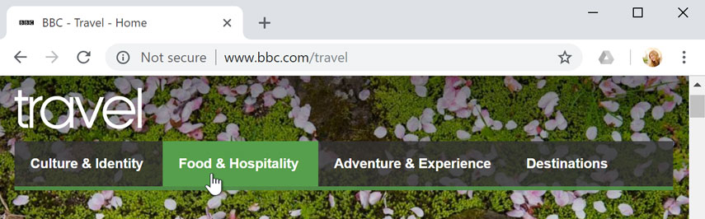

## If you see this icon, it means you've found a link. You'll find other types of links this way too. For example, many websites actually use images as links, so you can just click the image to navigate to another page.

# Navigation buttons

## The Back and Forward buttons allow you to move through websites you've recently viewed. You can also click and hold either button to see your recent history.

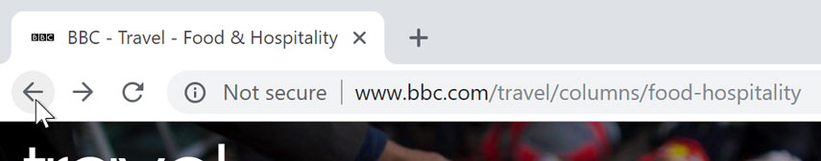

## The Refresh button will reload the current page. If a website stops working, try using the Refresh button.

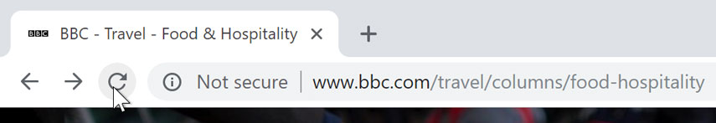

# Tabbed browsing

## Many browsers allow you to open links in a new tab. You can open as many links as you want, and they'll stay in the same browser window instead of cluttering your screen with multiple windows.

## To open a link in a new tab, right-click the link and select Open link in new tab (the exact wording may vary from browser to browser).

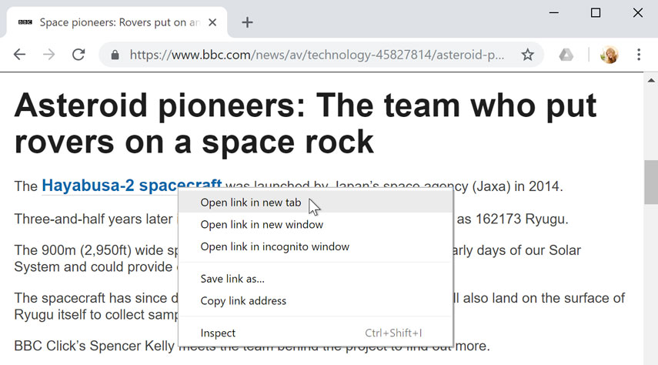

## To close a tab, click the X.

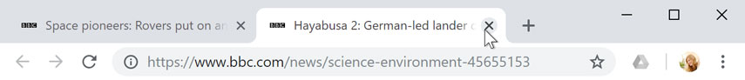

## To create a new blank tab, click the button to the right of any open tabs.

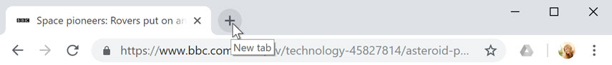

# Bookmarks and history

## If you find a website you want to view later, it can be hard to memorize the exact web address. Bookmarks, also known as favorites, are a great way to save and organize specific websites so you can revisit them again and again. Simply locate and select the Star icon to bookmark the current website.

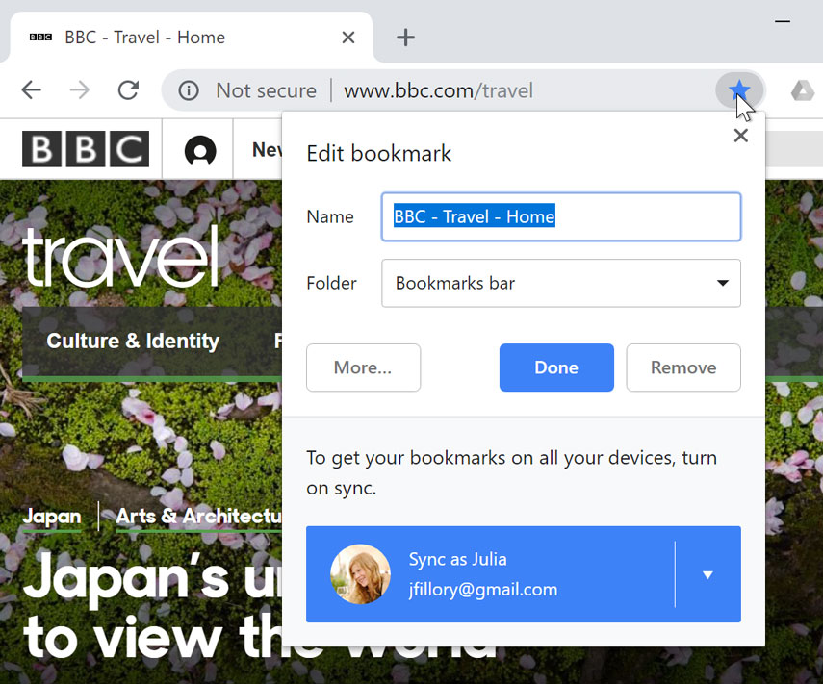

## Your browser will also keep a history of every site you visit. This is another good way to find a site you visited previously. To view your history, open your browser settings—usually by clicking the icon in the upper-right corner—and select History.

